

Product Catalog System

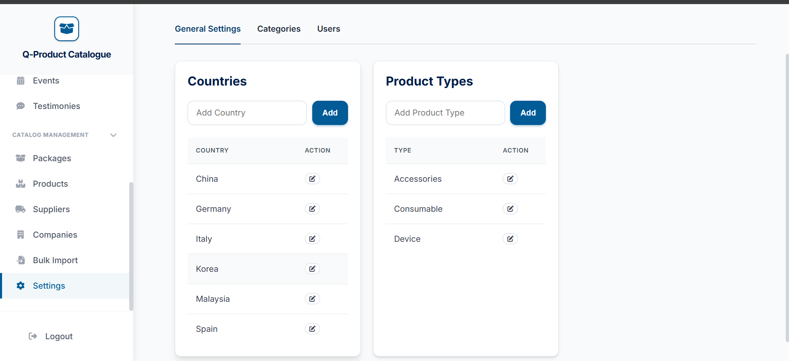
How to add a country
Go to the very bottom of the side bar to the Settings tab


Enter the country you want here
To enter countries in bulk you can follow the following steps:

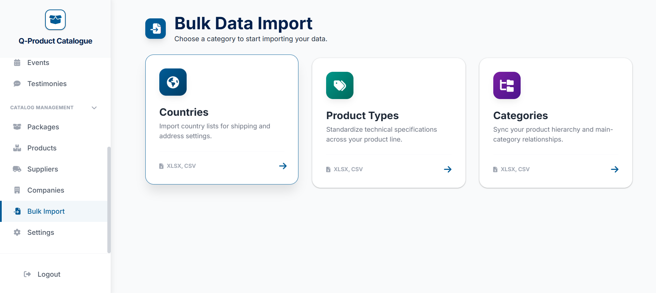


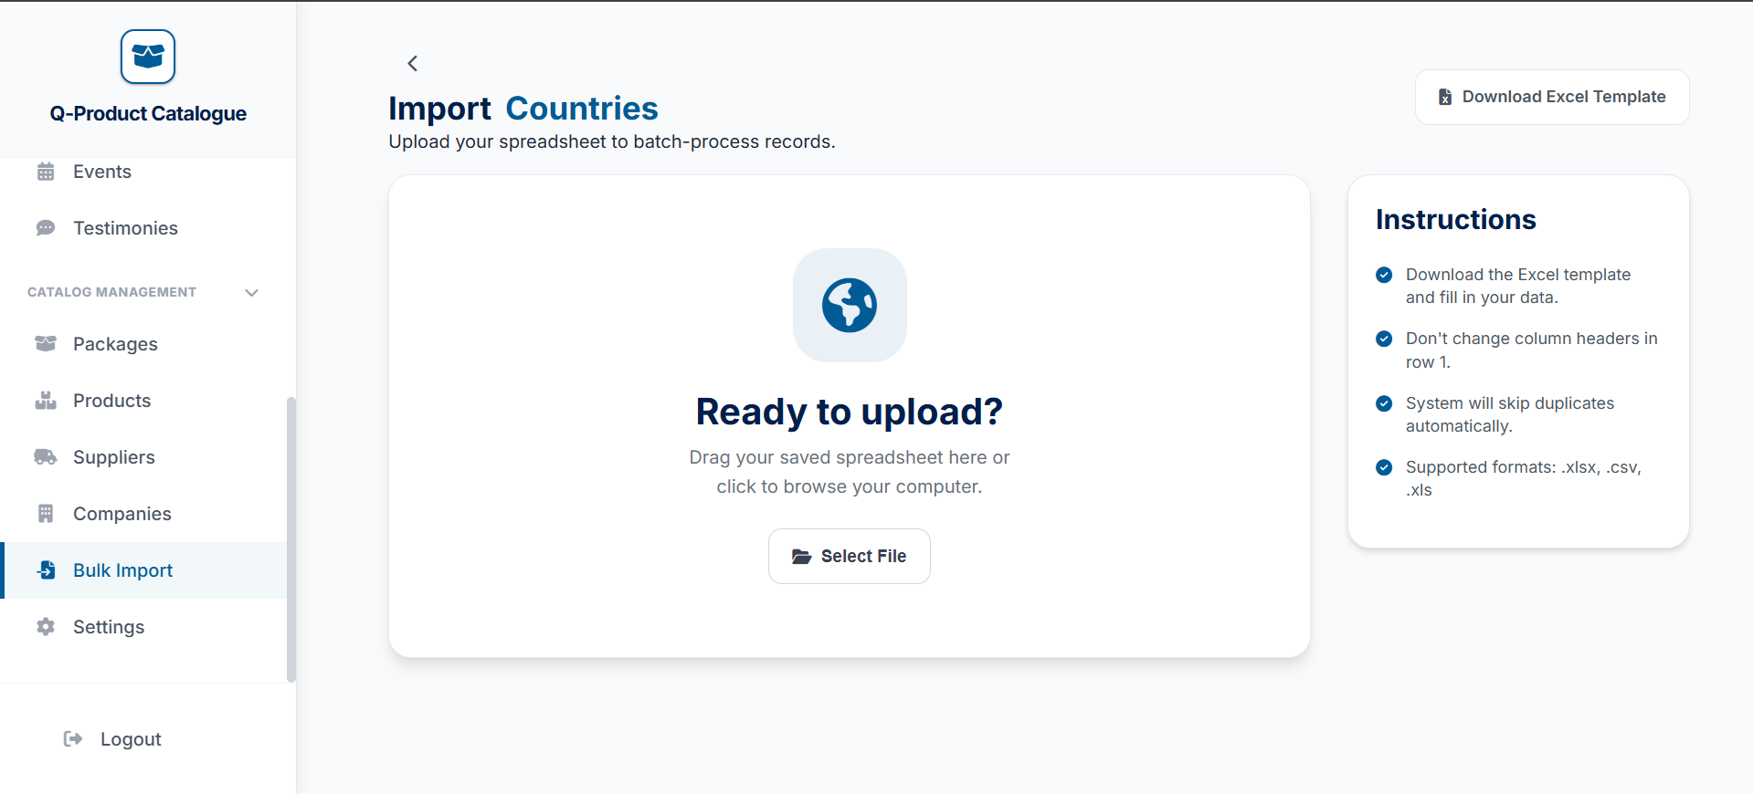
Then upload the filled template in here
Just download excel template and fill up the countries in that template
Then click on the Countries option
Go to the Bulk import tab
Enter the country you want here
Enter the country you want here

